Ideation Phase
Define the Problem Statements

Date | 7 July 2026
Team ID | SWTID-2026-2247
Project Name | Emotion Detection and Learning Support Engine
Maximum Marks | 2 Marks

Customer Problem Statement Template:
This template is used to define the core problem statements for the Emotion Detection and Learning Support Engine, capturing the users' point of view before building the emotion detection and guidance features.
A well-articulated customer problem statement allows the team to find the ideal solution for the challenges users face when trying to express and manage their emotions. Throughout this process, the team empathizes with users, which helps in designing an emotion detection and guidance experience that truly understands them.
Why This Matters:
Without a clearly defined problem statement, teams risk building features that don't map to real user pain points. For an emotion-aware system in particular, understanding exactly who the user is, what they are trying to achieve, and what emotional gap they are experiencing is what shapes accurate model design, believable AI responses, and a genuinely supportive user experience.
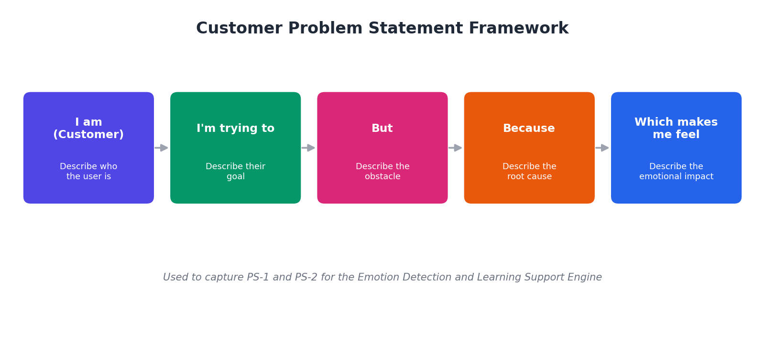
Example:
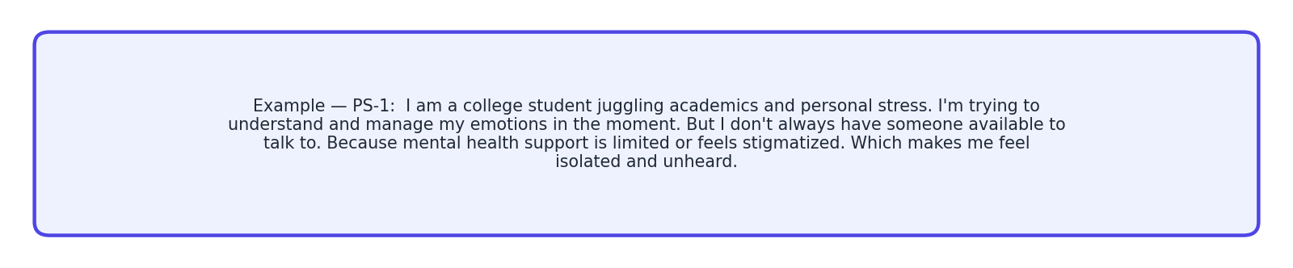
Problem Statement (PS) | I am (Customer) | I’m trying to | But | Because | Which makes me feel
PS-1 | A college student juggling academics and personal stress | understand and manage my emotions in the moment | I don't always have someone available to talk to | mental health support is limited, costly, or feels stigmatized | isolated, unheard, and anxious
PS-2 | A working professional facing daily pressure and mood swings | get quick, empathetic guidance when I'm frustrated or anxious | generic self-help content doesn't address my specific emotional state | most tools don't detect nuanced or mixed emotions accurately | unsupported and disconnected from the tools meant to help

